ASSIGNMENT NO 4
Q1. Explain link Budget analysis in wireless system.
OR
Derive an expression to measure required transmitted power at station with link budget expression
Link-Budget Analysis of a wireless link
Systematic listing
• Power losses
• Gains
of different intermediate components in the transceiver chain
Components of a typical Wireless link budget:
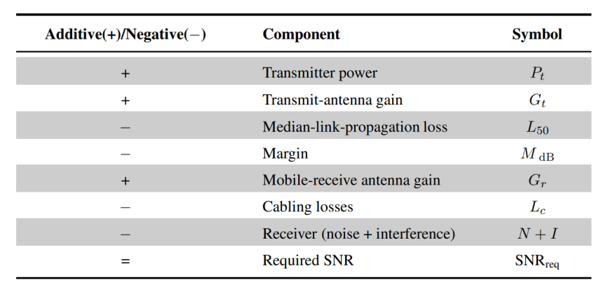

link-budget expression for the SNR required is given as
SNRreq = Pt ( dB) + Gt ( dB) − L50 ( dB) − M dB + Gr ( dB) − Lc ( dB) − (N + 1) dB
From the above the required transmit power is given as
Pt ( dB) = SNRreq − Gt ( dB) + L50 ( dB) + M dB − Gr ( dB) + Lc ( dB) + (N + 1) dB

Q2.Define Grade of service and blocking probability for lost call system and explain its Significance.
Cellular systems employ the principle of trunking to meet the demands of a large number of users, with a limited number of channels.
• one-to-one or dedicated channel allocation results in wastage of resources as the probability that all users are active at a given instant of time is low.
• Practically, only a few channels are necessary to meet the demands of users as they are random in nature.
• The large number of users share these limited number of channels, which is basically statistical multiplexing, i.e., assigning the channels to the various users based on demand
In a cellular system,
• less channels in each cell are shared by a large number of subscribers the cell. In a landline or a PSTN network
• few trunck lines at the exchange for a large number of subscriber
• customers on these lines have to share the limited number of outgoing lines at the telephone exchange.
• Thus, since the number of users is much greater than the number of channels available in the cell, there is always a finite probability that all the lines are occupied.
• Hence, when a new user requests a channel for communication, his call is blocked as there are no channels available for communication. This probability with which calls are blocked is termed blocking probability, or in cellular systems, is also termed grade of service

Q3.Explain the assumptions used in second erlang distribution for queuing systems
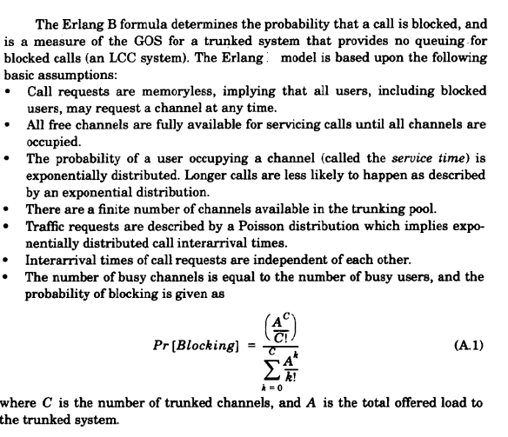
Q4. Define Blocking probability. With neat diagram and assumptions, explain Teletraffic system model.
Teletraffic System Model
In Teletraffic the random-call-arrival and s and call terminations are independent random
events, modeled by the Poisson distribution.
Probability that k calls arrive in a time duration t is given as
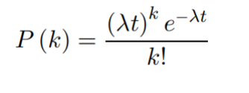
Consider now a cellular system with N available channels.
• The state of the wireless system that the number of channels occupied at a given point of time is given by a state diagram
Consider states S0, S1, . . . , SN , where Si denotes the state the i channels are occupied
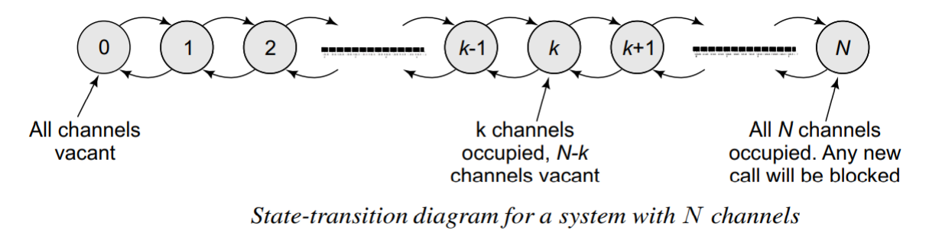
• In the state S0,all the channels are vacant,
• In the state SN ,all the N channels are occupied.
• Any new call arrival in the state SN will, be blocked.
• Let Pk denote the probability of the system being in the state k, i.e., k of the N channels are occupied.
• Therefore, PN denotes the probability of the system being in state N, in which any arriving call is blocked.
• PN denotes the blocking probability of the system

Q5. Each side of hexagon cell is 2/sqrt(3). A cellular system has N = 48 channels/ cell with blocking probability of 0.02. Further, traffic per user is 0.04E.the cell radius is 1km. With neat diagram, Calculate no. of users supported in a area of 900 km2 . Total traffic is 38.4E
Consider below numerical. Only change in the Area .
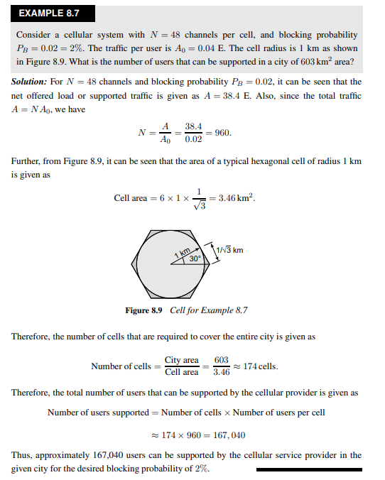
Q6.Draw and explain Tele-traffic Theory system for 100 users with 100
channels. [6]
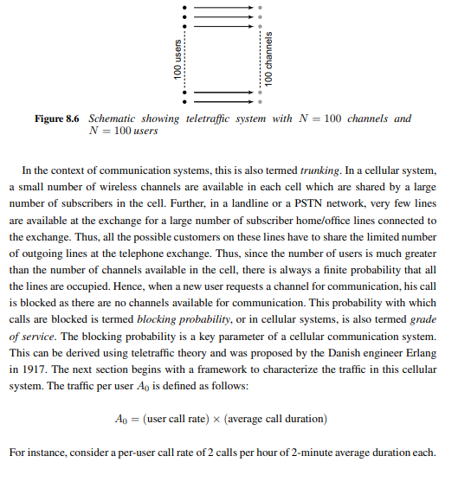
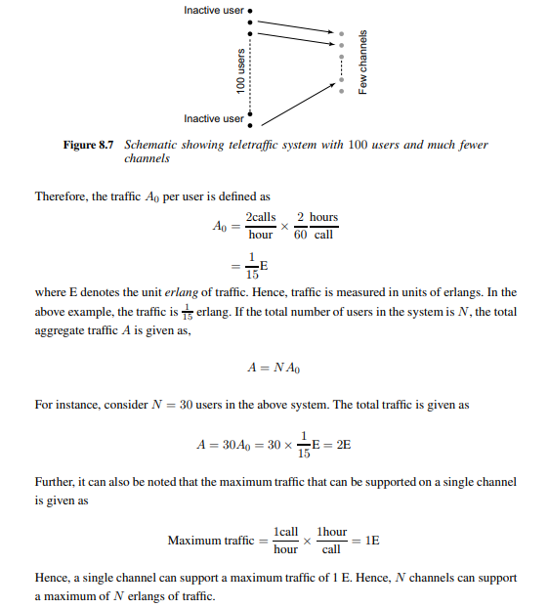

Q7.Describe the significance of listing Power losses and Gains of different intermediate components in the transceiver chain for Link-Budget Analysis. [6]

To plan the installation and deployment of a comprehensive wireless network, it needs to characterize the performance of the communication system in terms of
• The transmitted power
• The total load in terms of users that can be supported by the network
• The strength of the transmitted wireless radio signal decreases as the distance of propagation increases.
• Radio waves follow an inverse square law for power density: the power density is proportional to the inverse square of the distance.
• Every time we double the distance, we receive only one-fourth the power.
• The signal strength at the mobile is a function of the distance d. Hence, we need models which predict the mean signal strength at the receiver as a function of the separation between the transmitter and the receiver. These models are also termed large-scale propagation models.
Link-Budget Analysis of a wireless link
Systematic listing
• Power losses
• Gains
of different intermediate components in the transceiver chain
Components of a typical Wireless link budget:

link-budget expression for the SNR required is given as
SNRreq = Pt ( dB) + Gt ( dB) − L50 ( dB) − M dB + Gr ( dB) − Lc ( dB) − (N + 1) dB
From the above the required transmit power is given as
Pt ( dB) = SNRreq − Gt ( dB) + L50 ( dB) + M dB − Gr ( dB) + Lc ( dB) + (N + 1) dB

Q8.Classify path loss models of different types of cells. Write only the expression for median path loss under Hatta model for small to medium sized city signifying the importance of mobile antenna correction factor.

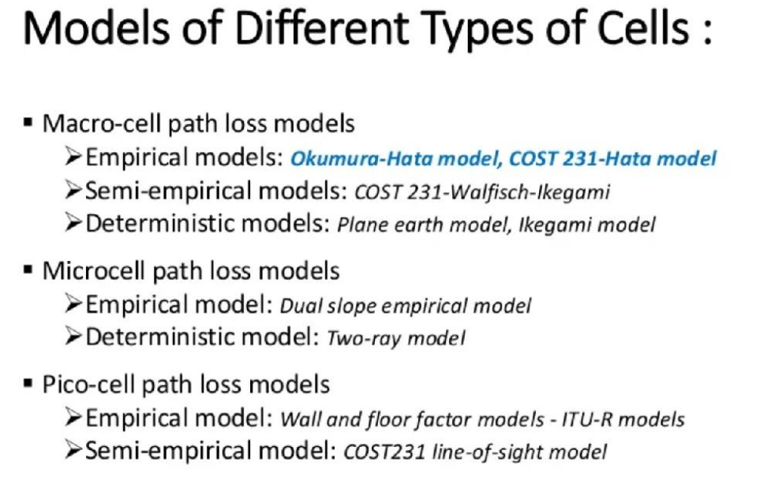
Hata Model
The Hata model is another popular model
• Signal strength prediction
• Proposed by the Japanese engineer Masaharu Hata in his 1980
• Hata model presents an analytical approximation for the graphicalinformation-based Okumura model
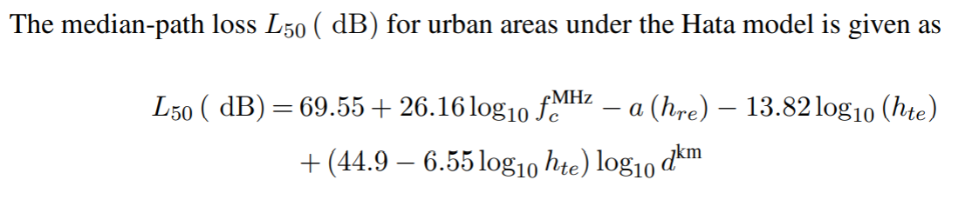
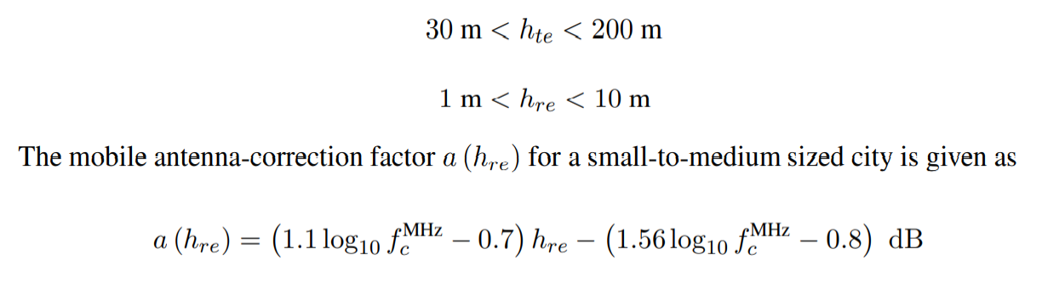
The quantity Amu (fc, d) is a correction factor as a function of the carrier frequency fc and distance d.This has been plotted for several values of fc, d

